**Home Security System using ESP32**

NAME: **GEORGE NICHOLAS A**

**Requirements:**

* ESP 32
* pir-motion-sensor
* dht22
* Buzzer
* Servo Motor

**Circuit diagram:**

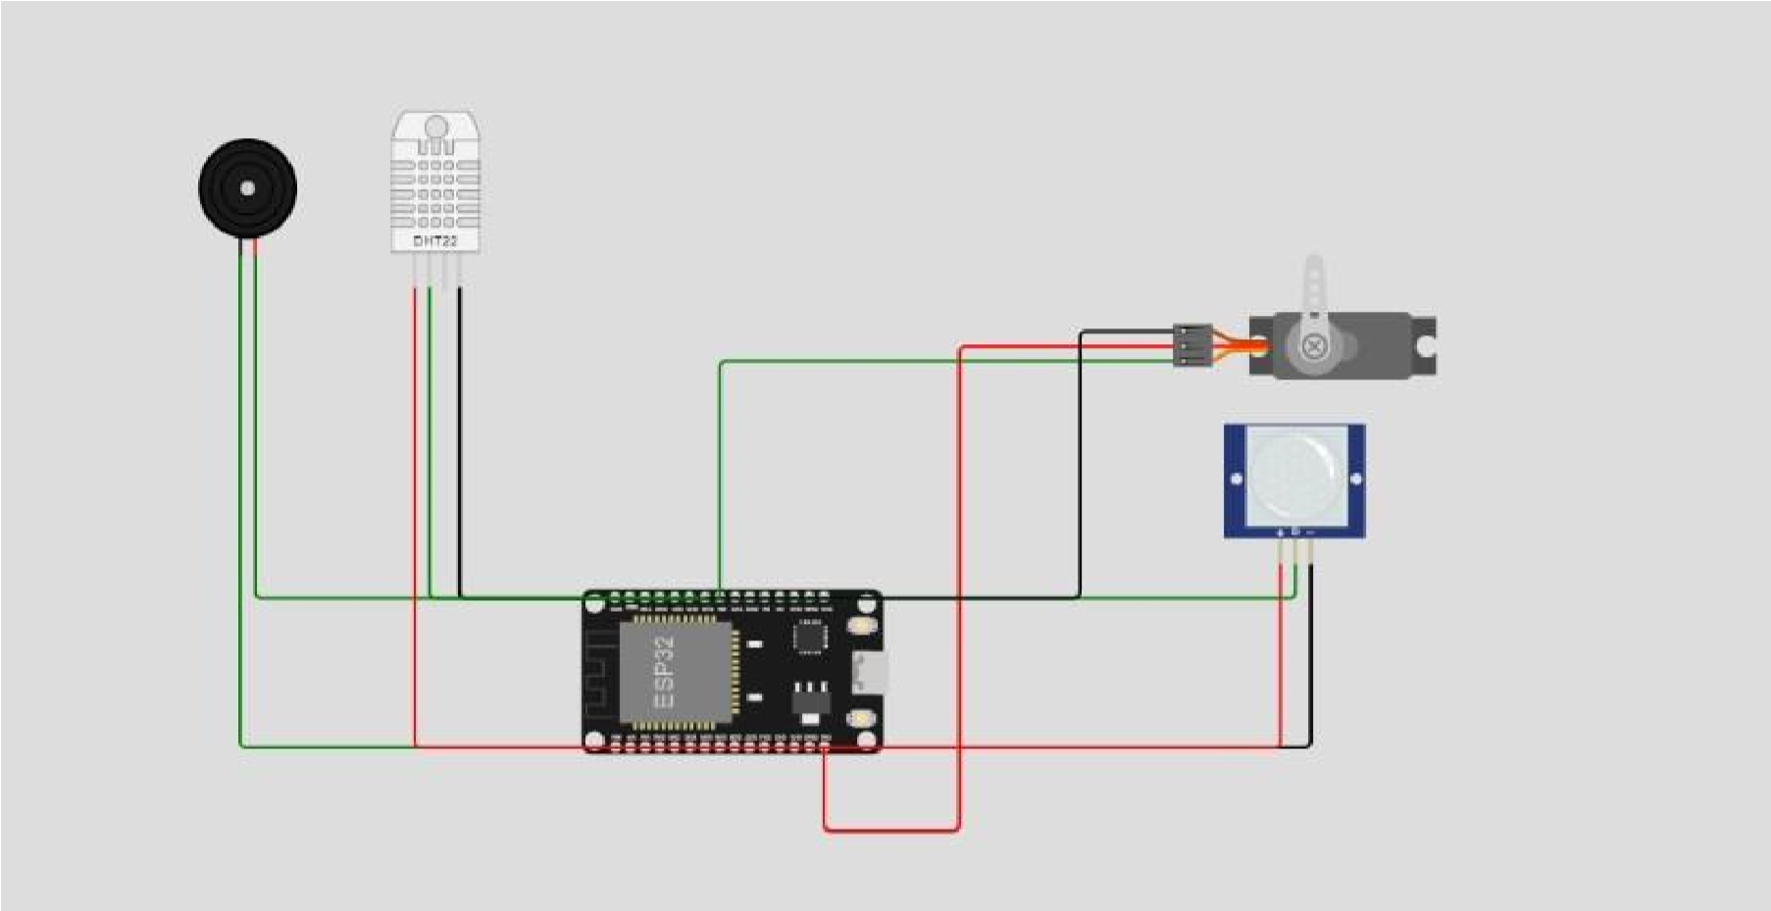

**Connection details**

* Buzzer 
  1. Positive → Pin No 15
  2. Negative → GND
* Pir motion sensor 
  1. OUT → Pin No 2
  2. VCC → VIN
  3. GND → GND
* Servo Motor

|  |  |
| --- | --- |
|  | 1. PWM → Pin No 5 2. Negative → GND 3. Positive → VIN |
| • | dht22   1. SDA → Pin No 18 2. VCC → VIN 3. GND → GND |
| 4. NC → No connection |

***Source Code:***

#include <ESP32Servo.h>

#include <DHT.h>

// PIR sensor const int pirPin = 2; bool motionDetected = false; // DHT22 sensor const int dhtPin = 18; #define DHTTYPE DHT22 DHT dht(dhtPin, DHTTYPE); float temperature; float humidity;

// Buzzer const int buzzerPin = 15; // Servo motor const int servoPin = 5; Servo doorLock; void setup() { pinMode(pirPin, INPUT); pinMode(buzzerPin, OUTPUT);

doorLock.attach(servoPin);

**Serial**.begin(9600);

}

void loop() { // Read PIR sensor motionDetected = digitalRead(pirPin) == HIGH;

// Check if PIR sensor detected motion if (motionDetected) {

tone(buzzerPin, 1000); doorLock.write(90); // unlock delay(8000); doorLock.write(0); // lock

} else { noTone(buzzerPin); doorLock.write(0); // lock

}

// Read temperature and humidity from DHT22 sensor humidity = dht.readHumidity(); temperature = dht.readTemperature();

**Serial**.print("Temperature: ");

**Serial**.print(temperature);

**Serial**.print(" C, Humidity: ");

**Serial**.print(humidity);

**Serial**.println(" %");

delay(200);

}